Constellation-X Black Hole Science

Michael Garcia (SAO), Nicholas White (GSFC), Harvey Tanabaum (SAO), Rob Petre (GSFC), Jay Bookbinder (SAO), and Ann Hornschemeier (GSFC).

The Constellation X-ray Mission (hereafter Con-X) is one of two flagship missions in NASA’s Beyond Einstein Program. The 2000-2010 Decadal Survey ranks Con-X next in priority after JWST among large space observatories. As a flagship mission, Con-X will naturally address a broad range of astrophysical questions, spanning solar system, stellar, Galactic, and cosmological studies. One of the primary and driving science topics for Con-X is the study of black holes. As is appropriate for this symposium, we limit this contribution to a discussion of black hole studies only.

Studies of supermassive black holes with Con-X will allow the first time resolved velocity measurements of the orbits of ‘test particles’ within a few gravitational radii of black holes. These measurements are enabled by the appearance of Fe Kα fluorescence lines in the x-ray spectra of material orbiting near the inner edge of the black hole accretion disk, and by the existence of individual fluorescent hot spots in this material. The figure to the left below shows a simulated image of these hot spots orbiting near the event horizon of a supermassive black hole. The figure to the right below shows a trailed spectrum of an individual hot spot from this image. The orbital motion of the Fe Kα line is easily detectable above the Poisson noise of the continuum. In the thin disk approximation which is applicable in these disks, the motion of these hot spot is the same as a free-falling test particle to 1%.

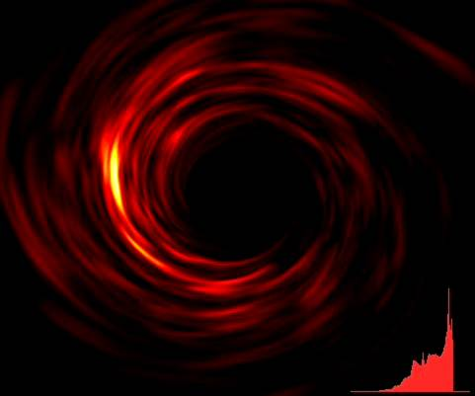
FIGURE 1: (left): A simulated image of the Fe Kα hot spots orbiting within a few gravitational radii of a supermassive black hole. The black in the center marks the event horizon boundary. A snap-shot of the Fe Kα spectrum from the simulated image is shown in the lower right corner. (right): The energy of the Fe feature from an individual hot spot vs. time as it would be detected by Con-X. Time in physical units for this 3 x 10⁷ solar mass black hole is shown on the horizontal axis. The noise in the spectrum is as predicted given the expected noise in the continuum.

Any given combination of black hole mass, spin, and hot spot radius will produce a specific energy/time track similar to that shown in the right hand side of Figure 1. By fitting the observed curves to theoretical curves we can very accurately determine spin and radius of the hot spot. The mass of the black hole is also very accurately determined simply from the scale of the time axis in the fit. In Figure 2 (left) we see the results of fitting this simulated data shown above. The input spin and radius are accurately recovered, and the error bounds are shown. If the Kerr metric properly describes the space-time around the black hole, the spin derived from other hot spots at different radii will be the same. Any deviation from Kerr may show up as a change in the spin with radius, or as tracks that do not fit the predictions. The capacity to perform these tests of strong gravity can be described by a figure of merit which is the product of the orbital timescale and observed flux. This figure of merit is shown in Figure 2 (right) vs. the orbital timescale. Black holes above the dashed line at 50 will allow these tests to performed with the baseline Con-X area assuming they have typical Fe Kα line strengths. Furthermore, the objects shown by diamonds have recently been observed to have Fe Kα lines of typical or higher strength. Ongoing observations may double this target list.

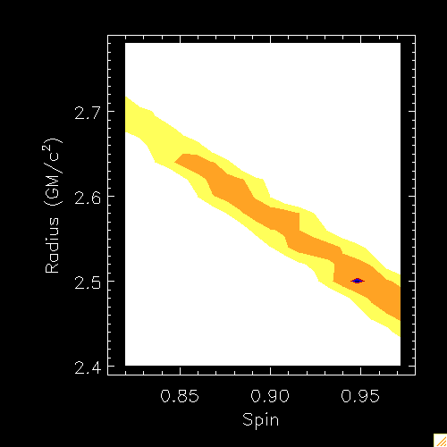
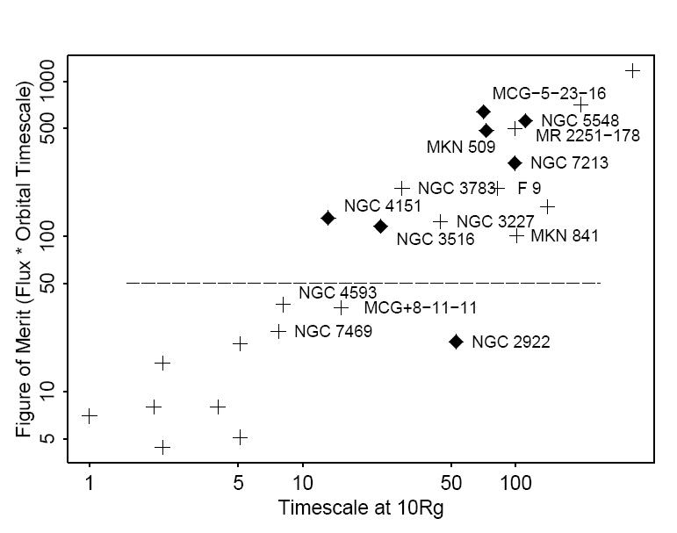
Figure 2 (left): By fitting theoretical orbital tracks to the data shown in Figure 1 (right) we can derive the spin and radius to high accuracy. Shown are the derived 1, 2 and 3 σ error contours. (right): The figure of merit required to perform these tests is a product of the x-ray flux and black hole orbital timescale, as shown in the vertical axis. Any object with a figure of merit above 50 is suitable. As we see here, there are numerous, identified targets which will yield data of sufficient quality to allow these tests of GR.

Beyond carrying out accurate tests of GR in the strong gravity regime, Con-X will greatly enhance our understanding of the evolution of supermassive black holes over cosmic time. The recent discovery that black hole and bulge mass of galaxies is closely correlated strongly suggests that black holes play an important role in the evolution of galaxies. One way in which Con-X will measure this evolution is by tracing the spin of black holes vs redshift, luminosity, and mass of galaxies and black holes. There are several hundred AGN covering a range of redshift, luminosity, and black hole mass for which very high S/N time averaged Fe Kα line profiles can be obtained and accurate spins measured. The x-ray spectrum and luminosity may give and estimate of the black hole mass independent of those derived from observations at other wavebands. Characterization of supermassive black hole spin, luminosity, and mass vs redshift will allow evolutionary models for supermassive black hole growth to be tested (for example, see the contribution in these proceedings by Bogdanovic, Brenneman, and Holley-Bockelmann).

At higher redshift and/or lower flux, Con-X will help us understand the cosmic x-ray background (CXRB). One way to look at this is to understand that Chandra has done what it was designed to do: resolve the CXRB into its constituent parts, which are dominated by accreting supermassive black holes. However, nearly 1/3 of these black holes have no counterpart in deep HST images, and another 1/3 appear to be normal galaxies with no hint of their AGN nature other than their x-ray luminosity. Understanding the AGN which make up the CXRB, measuring their redshifts, etc. will require high resolution X-ray spectra as obtainable with Con-X. Moderate exposures will reveal AGN type and redshift from the X-ray spectrum alone.

The coeval growth of supermassive black holes, galaxies, and more generally cosmic structure is sometimes referred to as ‘cosmic feedback’. This interaction is readily apparent in Figure 3 which shows a combined Chandra and radio image of Hydra A. Here we see the supermassive black hole jets blowing a pair of bubbles in the surrounding cluster gas which feeds the black hole. Simulations of the growth of cosmic large-scale suggest that this feedback regulates the growth of galaxies. Understanding this feedback may explain the M-σ relation (see the contributions in these proceedings by Batcheldor, Fukumura, Tundo). The spatially resolved spectroscopy by Con-X is required to probe the interactions between the jets and gas, and high spectral resolution is required to determine the mass outflow rates.
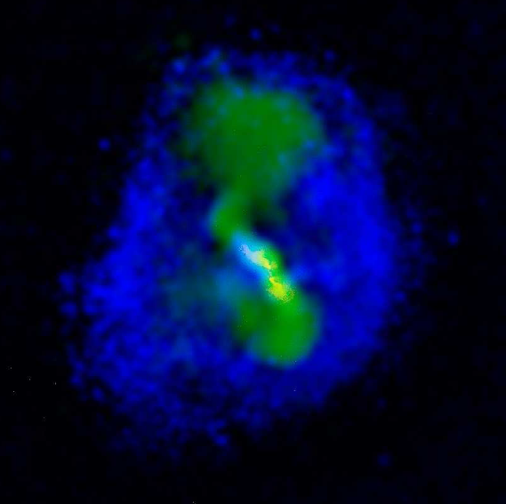
Figure 3. A combined x-ray and radio picture of the Hydra A galaxy cluster. The radio jets are seen expanding vertically through the x-ray emitting cluster gas. Accretion of this cluster gas is what powers the central black hole, so we are witnessing cosmic feedback in action here.

In recent years studies with Chandra have made it plain that there are black holes which are not the central supermassive black holes we typically find in galactic centers, but which are ultra-luminal for typical (~10 solar mass) Galactic black holes. These ultra-luminal sources may be intermediate mass black holes (IMBH). The evidence for the existence of this new class of black hole – of intermediate mass – is good, but not definitive. Figure 4 (left) shows the x-ray luminosity versus measured accretion disk temperature for a number of stellar-mass black holes in the Milky Way and Large Magellanic Cloud, and a number of the brightest ultra-luminous X-ray sources in nearby galaxies. The sources in the upper left hand corner are IMBH candidates. If the luminosities are isotropic and Eddington limited, then the masses must be >>10 solar masses. The continuum spectra are as predicted by thin disk models for black holes >>10 solar masses.

Figure 4 (right) shows that Con-X can be definitive. This shows a simulated Con-X spectrum of the IMBH candidate NGC 1313 X-1, plotted as a ratio to a simple power-law model. A 100 ksec exposure with Constellation-X will not only reveal the cool accretion disk component glimpsed with XMM-Newton (Miller et al. 2003), but will clearly reveal the Fe Kα line and determine the IMBH spin. Con-X timing measurements may also reveal QPOs whose frequency scales with mass, giving independent evidence for masses >>10 suns.

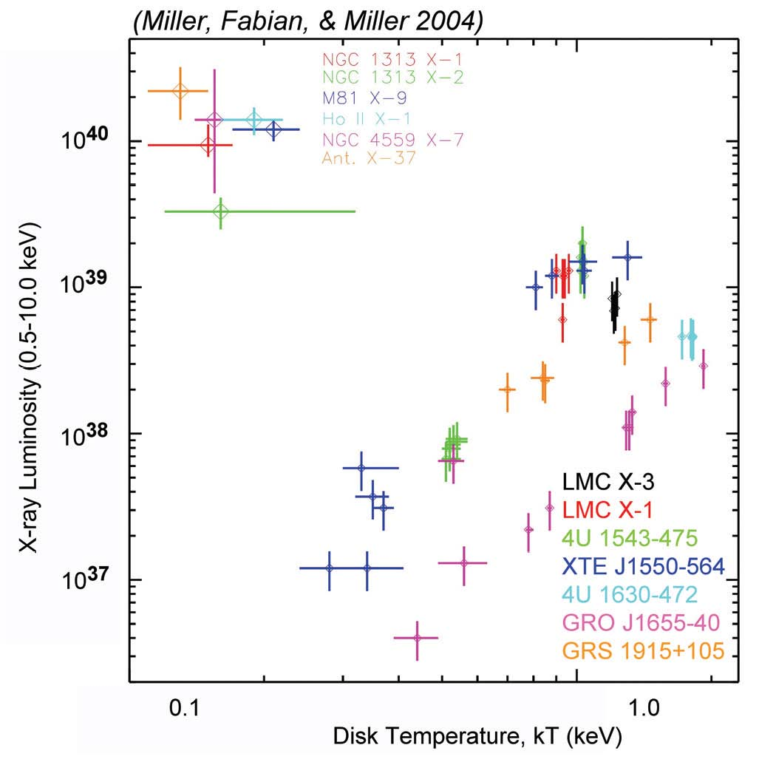
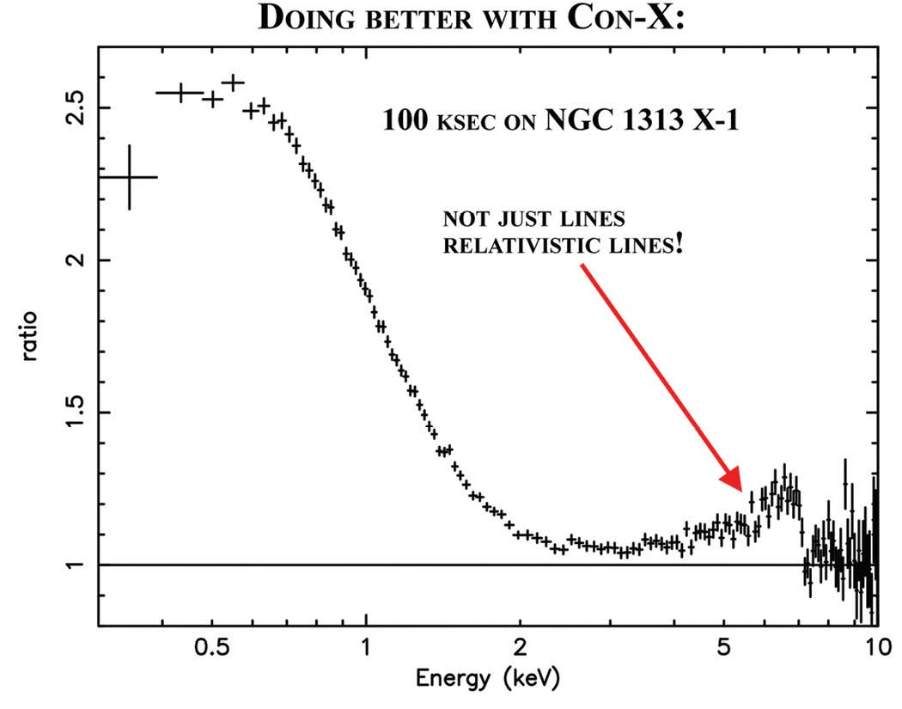
Figure 4 (left): The temperatures and luminosities of IMBH candidates in the upper left scale as expected from simple accretion disk physics, assuming that they have masses of 100 to 1000 solar masses. This provides good evidence these are IMBH. (right): A simulated Con-X spectrum of an IMBH candidate. The relativistic Fe Kα line is clearly visible, which (if detected) gives very good evidence for the intermediate mass nature of this black hole.

Some of the best evidence for the existence of black holes has been gleaned from studies of the so called ‘stellar mass’ black hole binaries which reside within the Milky Way. There are now close to 2 dozen of these binaries with secure dynamical mass measurements around 10 solar masses. Comparison of the luminosity of these black holes to binaries of similar orbital period but containing neutron star accretors provides some of the most direct evidence for the existence of event horizons in black holes (see the article by Narayan in these proceedings). Fe Kα lines are common in these stellar mass black holes. Figure 5 shows some examples of these lines in recently identified dynamically confirmed Galactic black holes. These lines allow the spin to be accurately measured, and allow testing of the scale invariance of the Kerr metric over eight orders of magnitude in mass. Con-X will retain high spectral resolution at the high counting rates typical of these Galactic black holes. The calorimeters on Con-X will be faster than those previously flown, and will allow at least CCD like spectral resolution at 1 Crab fluxes, improving over RXTE’s resolution by several times. Tuning parts of the calorimeter may allow the full spectral resolution up to even higher fluxes. The gratings will retain their full resolution at even higher fluxes.

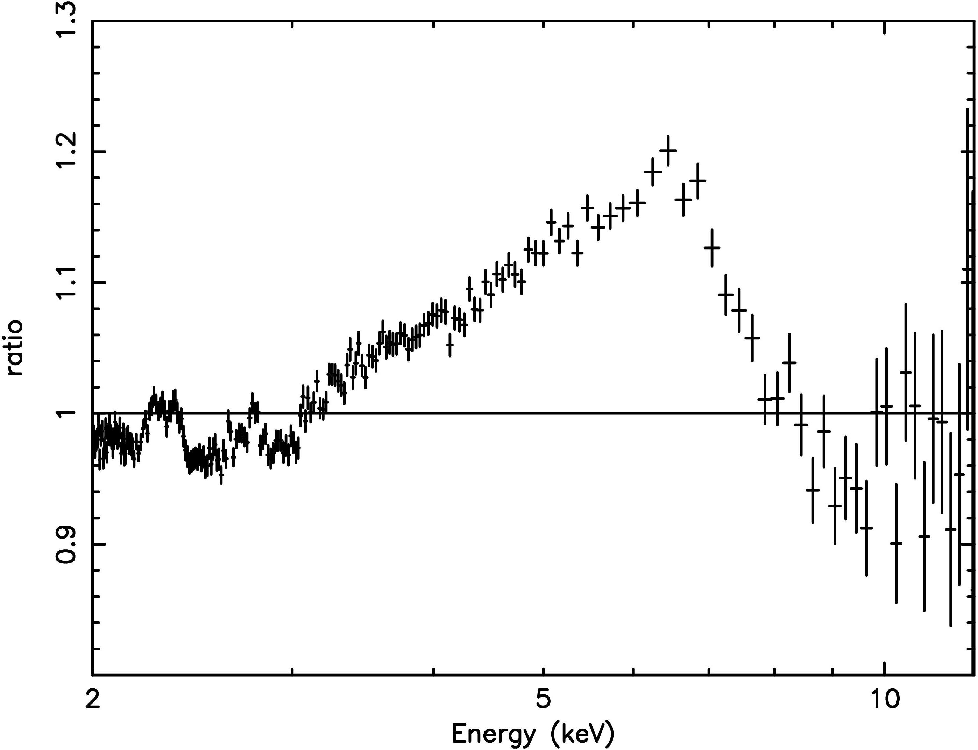
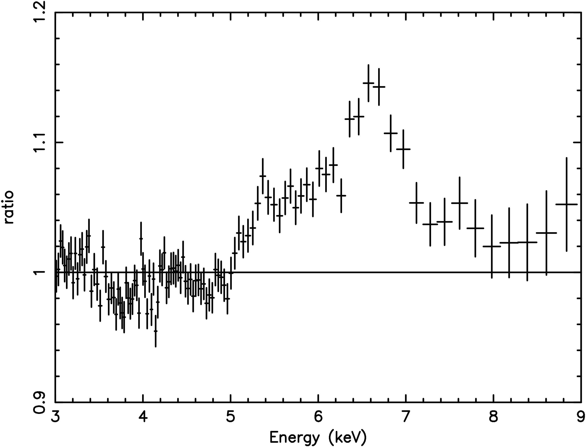
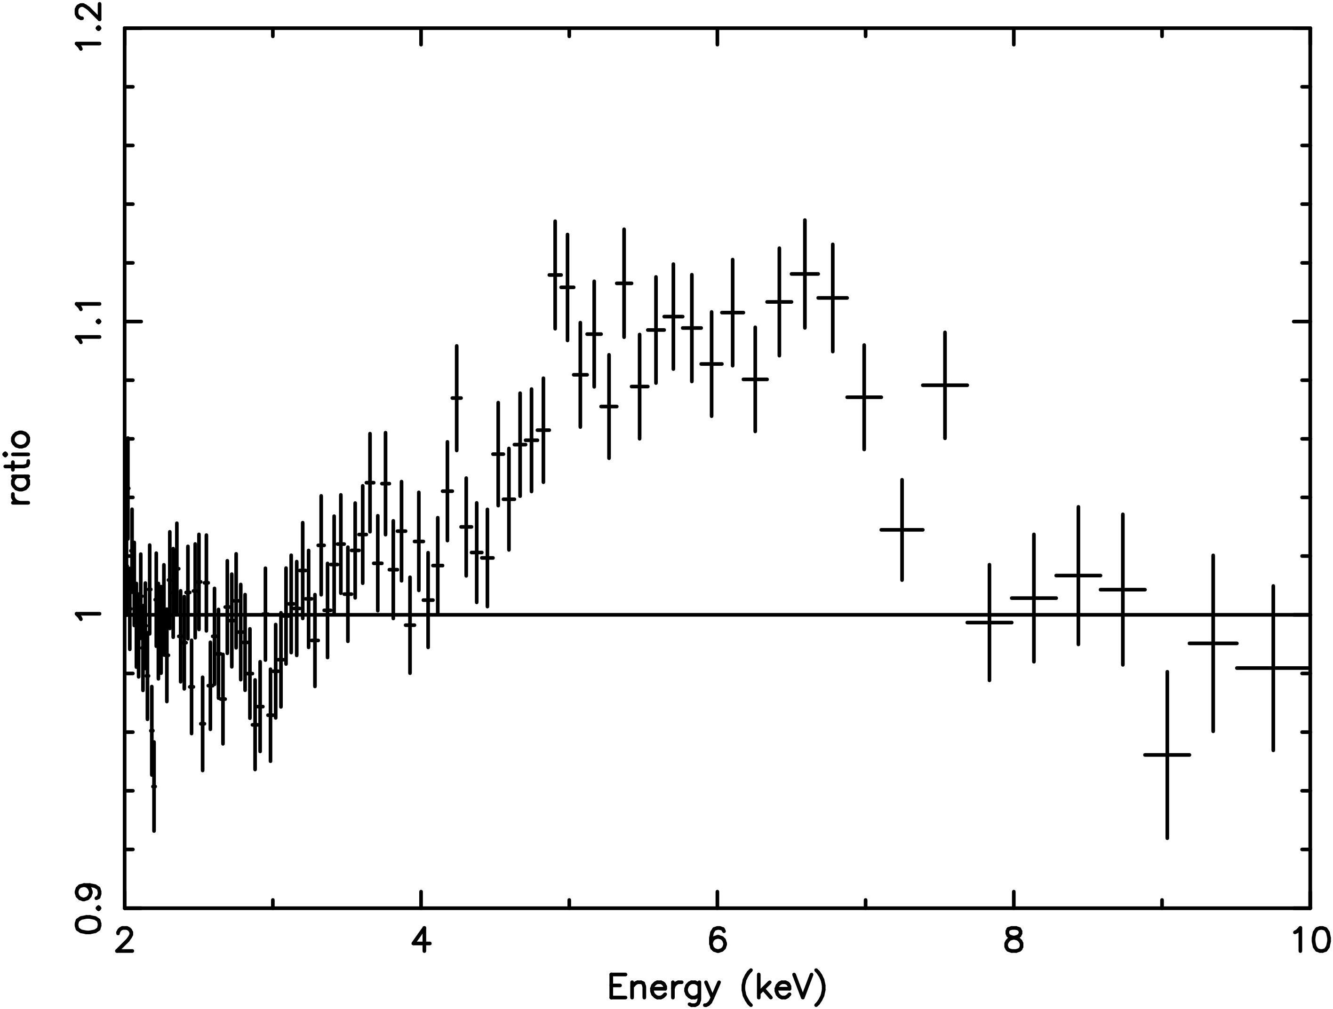
GRS1915+105
XTE J1550
GX3339-4
Figure 5: A gallery of Fe Kα lines in Galactic Black Holes. These lines are common in these nearby black holes.

In summary, we note that as an observatory class mission Con-X will allow breakthroughs in a wide range of astrophysics. Observations will be open to the entire astronomical community and selected via a peer-review process. Con-X will operate at L2 with an observing efficiency approaching 90%. Design lifetime is at least 5 years. The baseline configuration includes four large X-ray telescopes and two smaller high energy telescopes all housed in a single spacecraft.

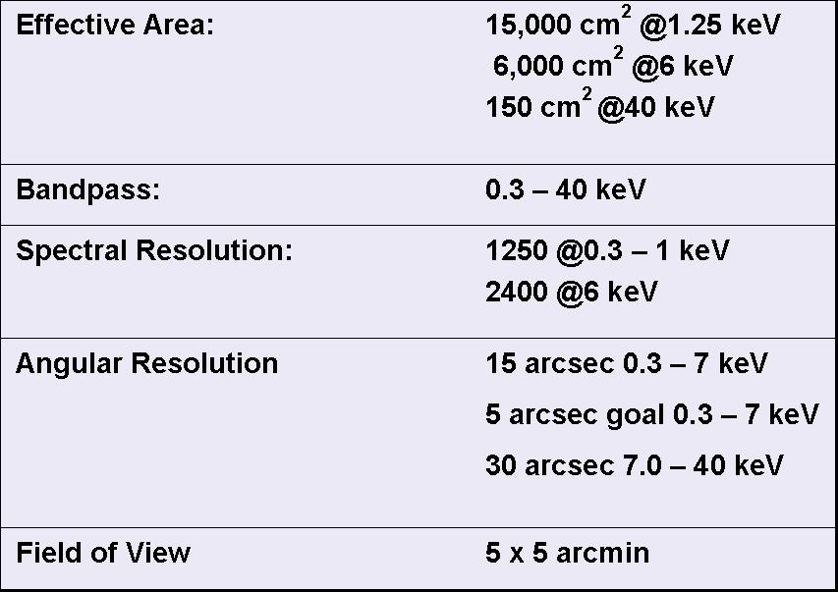
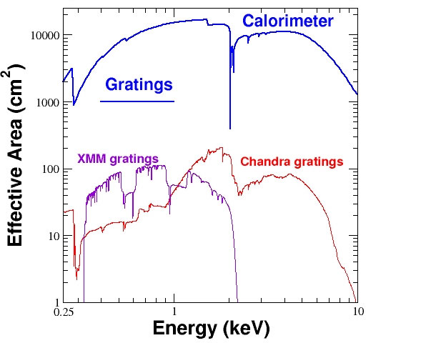

Figure 6 (left): The Con-X gratings and calorimeter will provide a 100x increase in effective area for high resolution spectroscopy as compared to currently available and/or planned missions. (right): The science investigations set these baseline requirements on the observatory.

